CSMAXXXING Github tutorial (link: shiorud/CSMAXXXXXXXXING)

Pick your own workspace
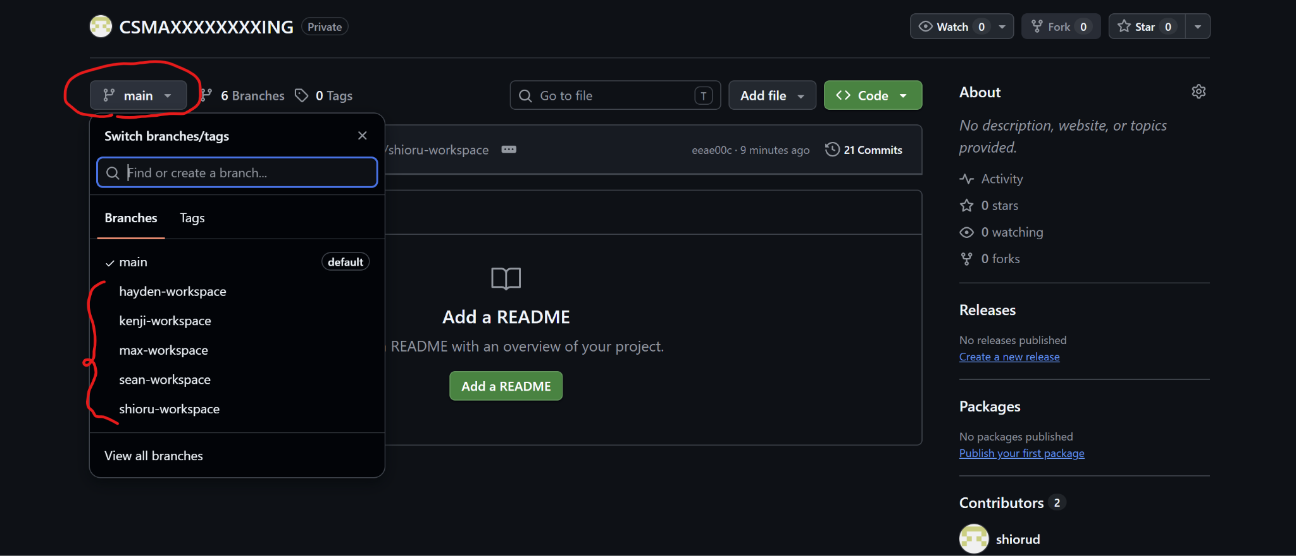
So basically the github repository is to track/journal the progress of the project, so if you updated/added something towards the project upload the files after you’re done for the day
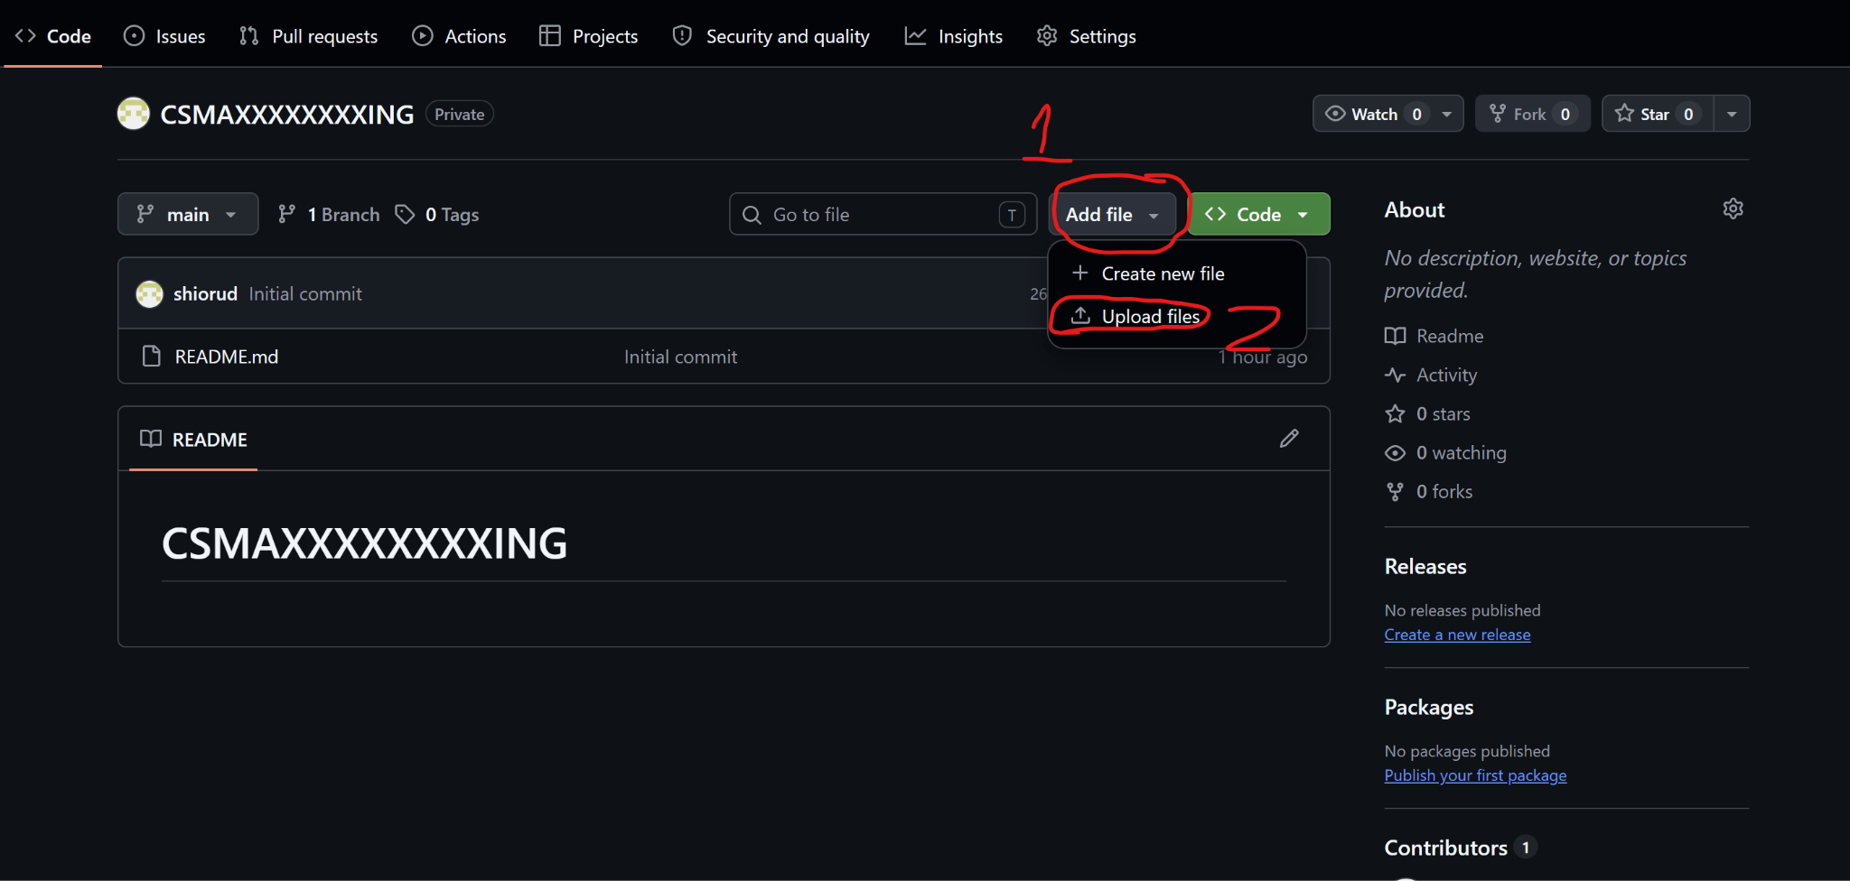

Upload the file and add a description on what you changed/added. Please make sure that the updated file you want to upload matches with the previous file’s name. Make sure you upload on your own workspace
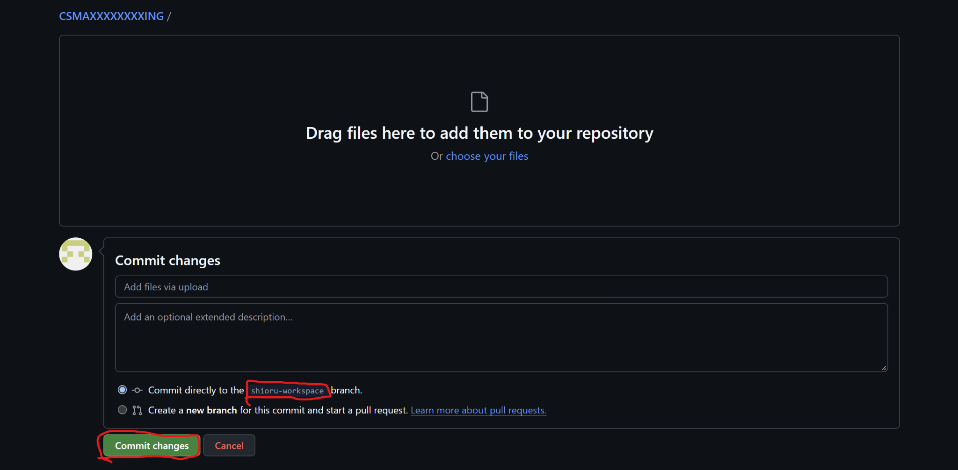

Newest uploaded files should be visible here
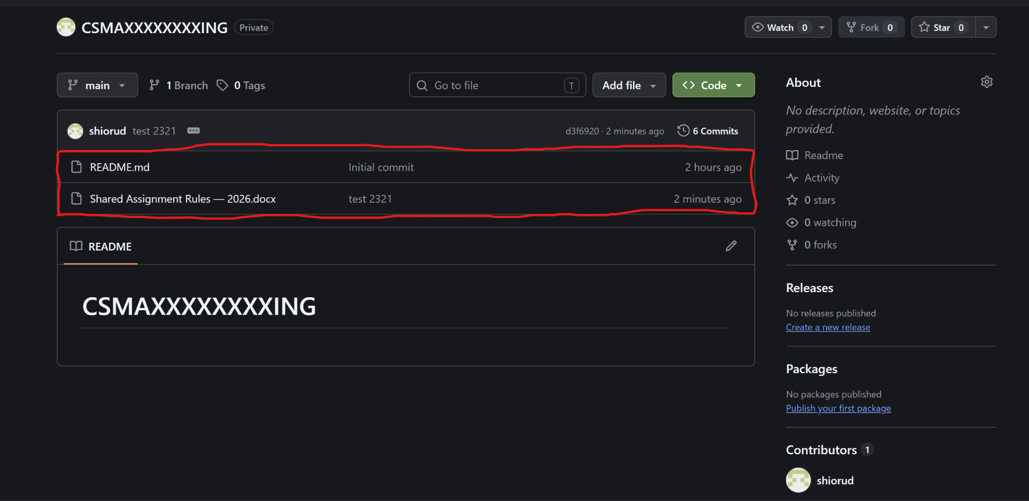
COMMITS
View commits by pressing the button below
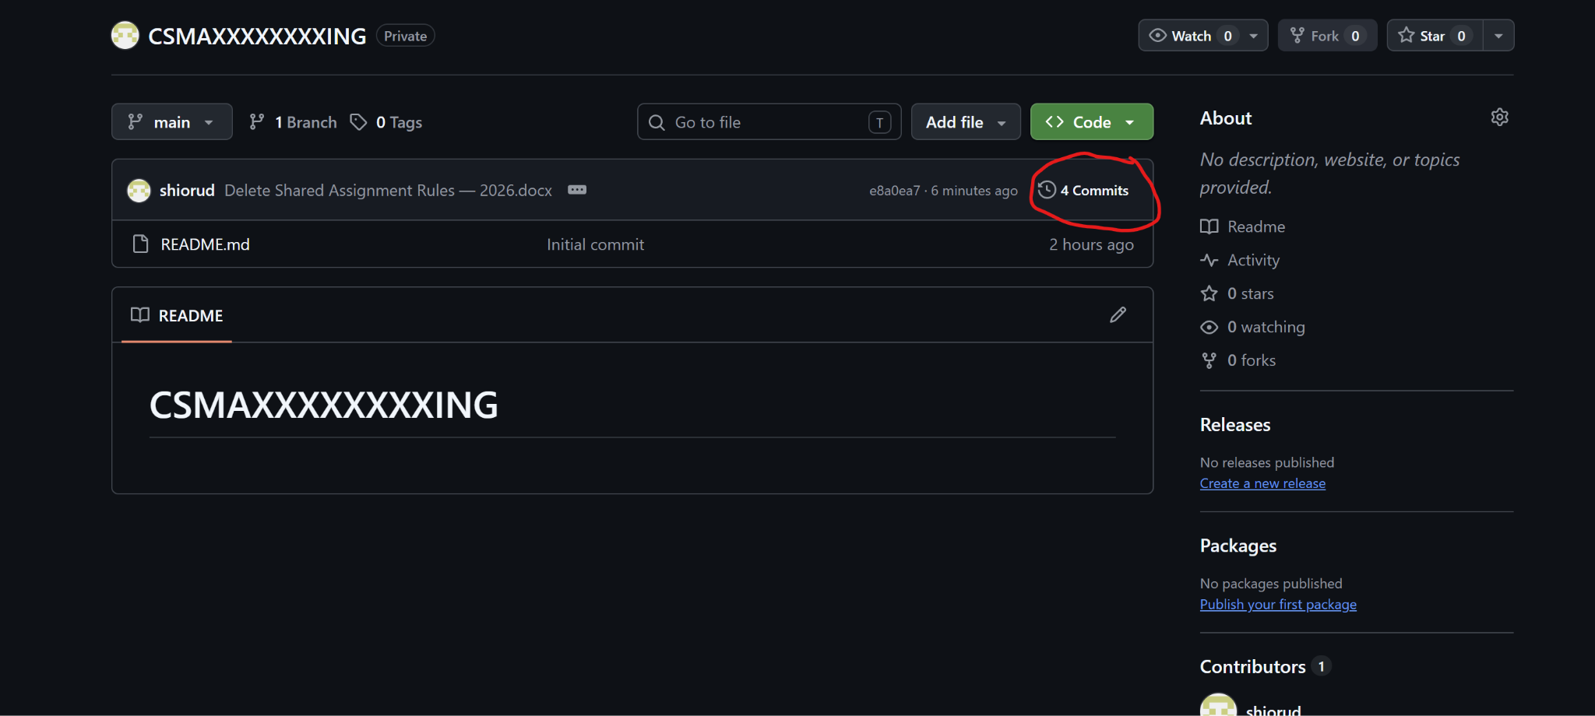

If you want to see past activity just click on the commit you want to view
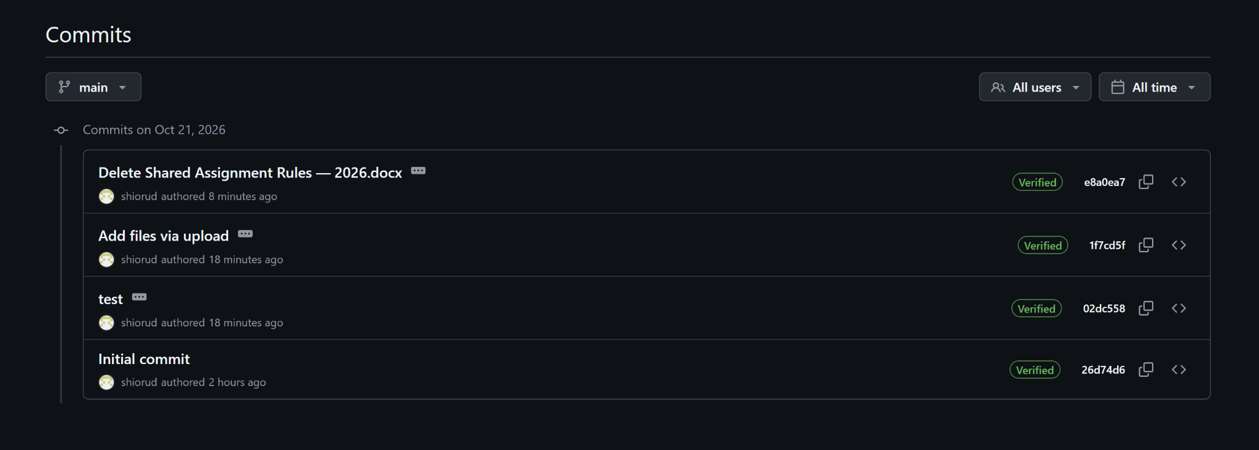

↓↓↓↓↓↓↓↓↓↓↓↓↓↓↓↓↓↓↓↓↓↓↓↓↓↓↓↓↓↓↓↓↓↓↓↓
You are able to view the uploaded file(s) and comment on the commit
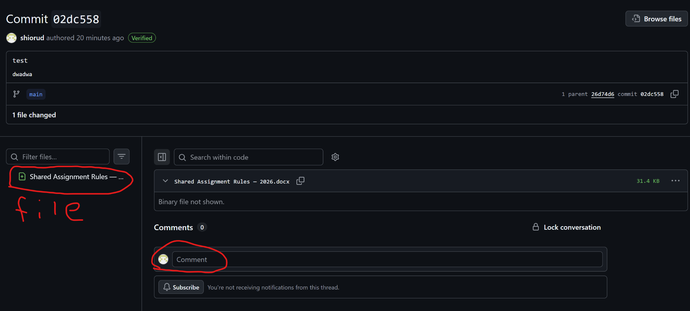

Deleting files

Pick the file you want to delete
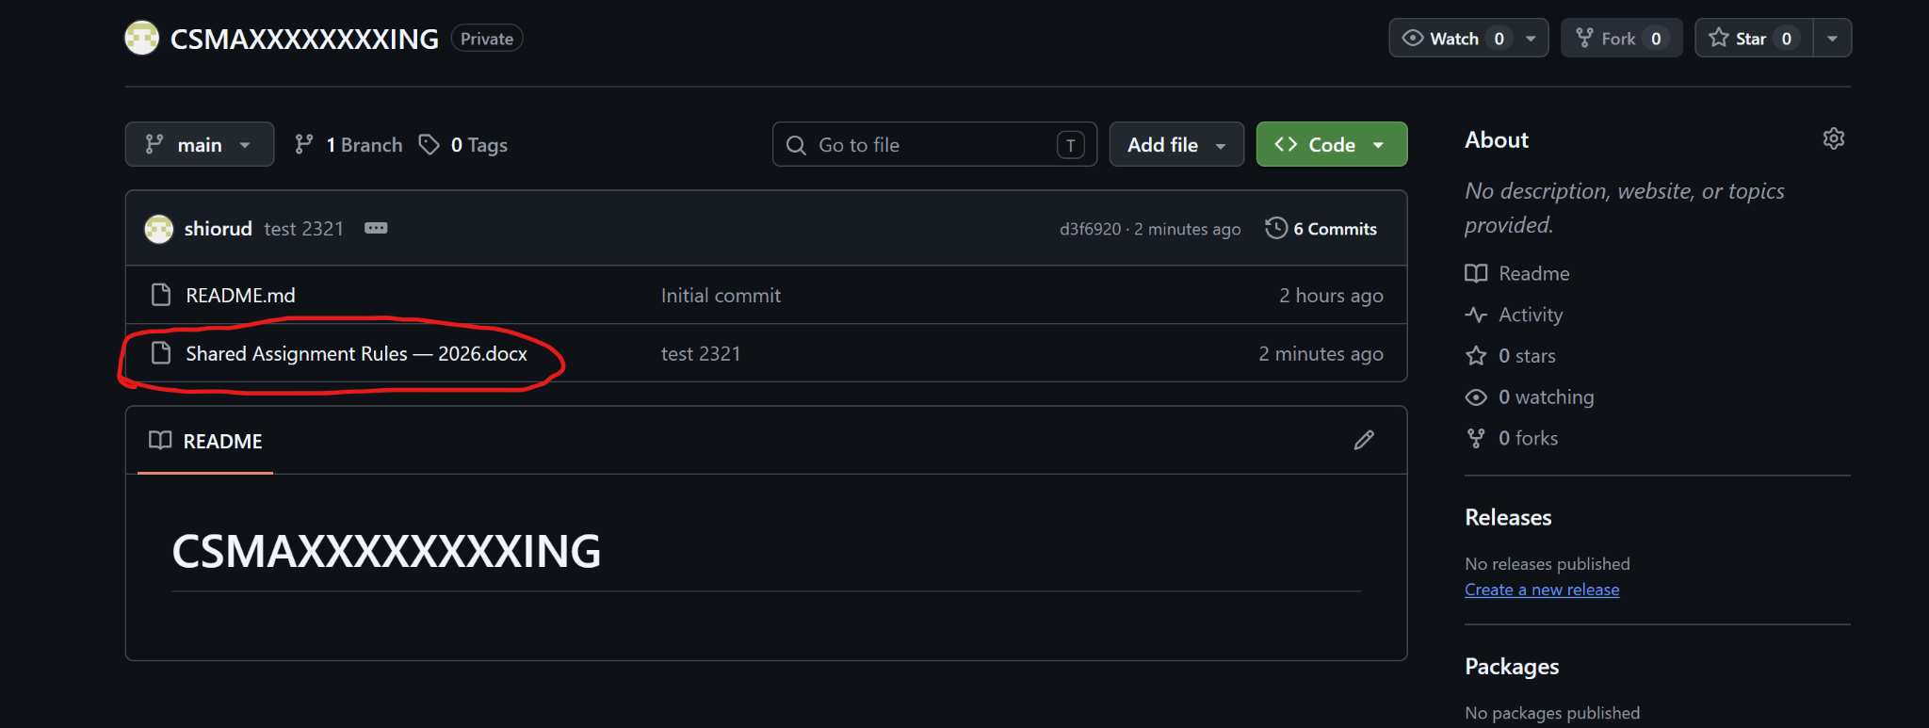
Do the following
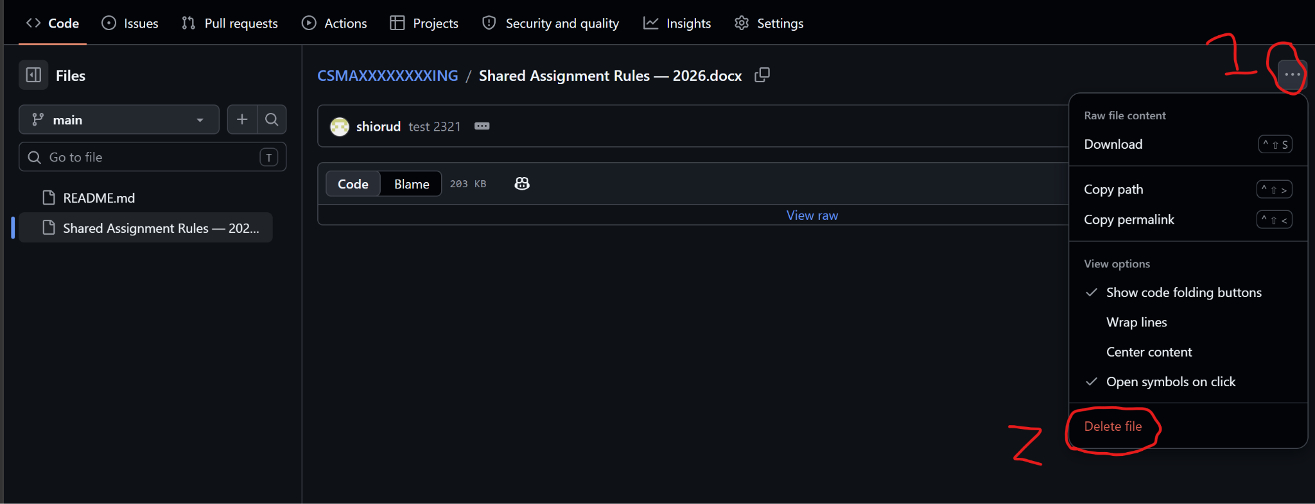
And commit the changes
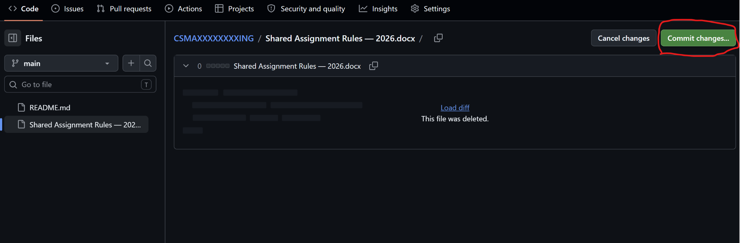
Then press the button below (add a description if need
